Test Plan

1. A list of the interactive components and their expected behaviour, e.g. what events are handled by which elements and what behaviours are expected to happen when the events occur.

Navigation bar: “click” event, showing different main content correspondingly.

Navigation bar: “scroll” event, sticky header.

Navigation icon: “mousemove”, “mouse leave” event, changing the size of search icon.

Navigation icon: “click”, search input shown, and login/register disappear; “click” again search input disappear.

2.

Test in FireFox, Google Chrome.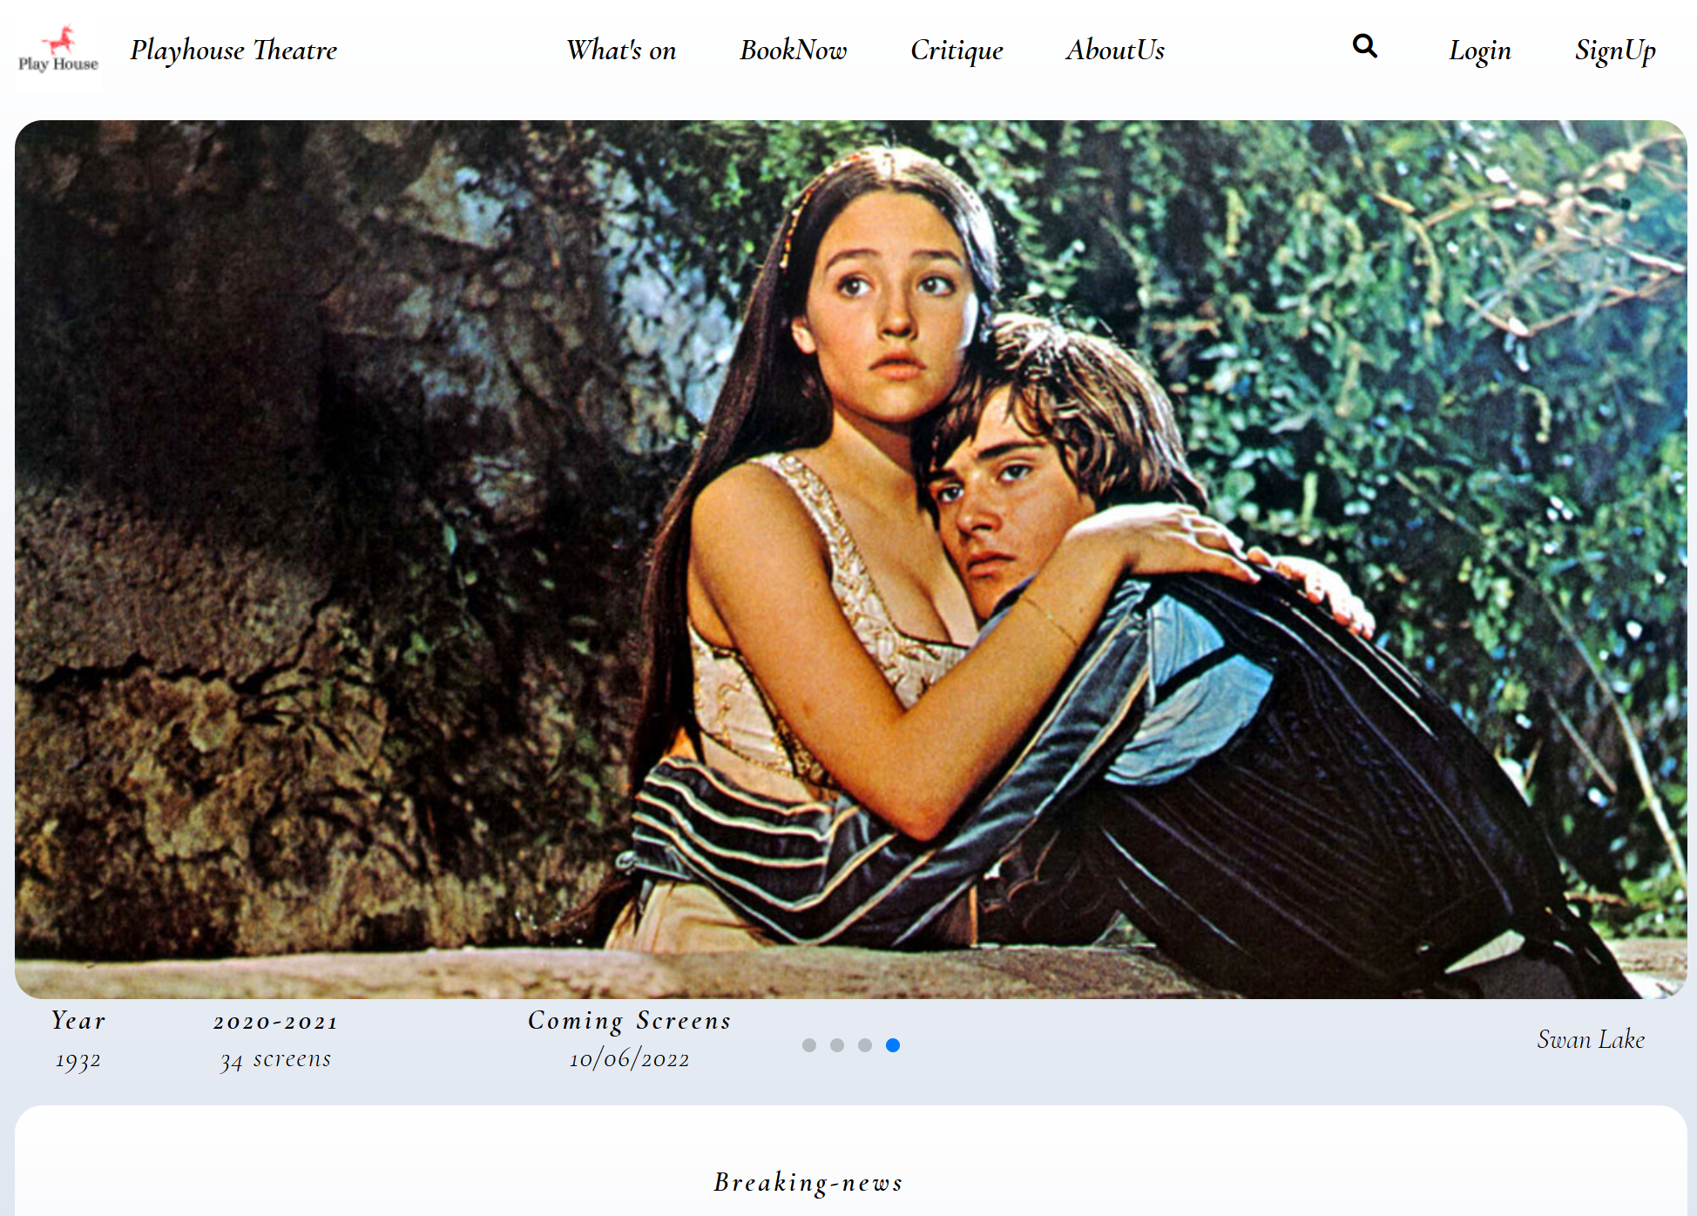

Book Now Page

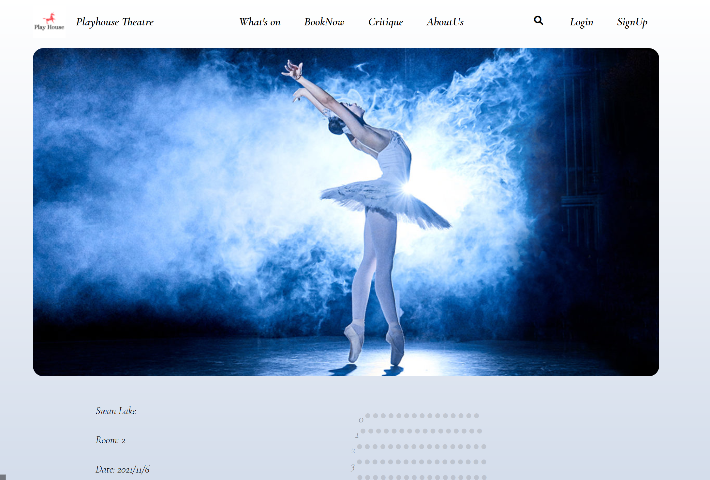

Critique Page and AboutUs Page

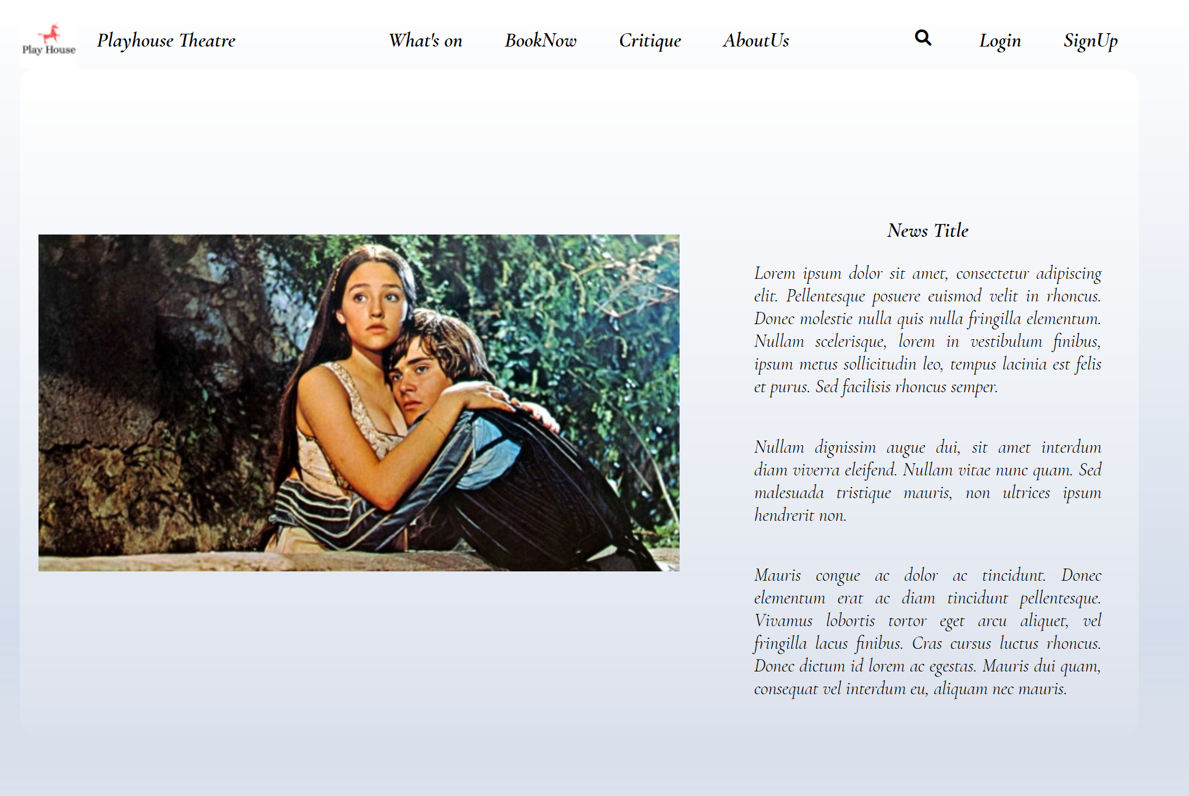

login and register page

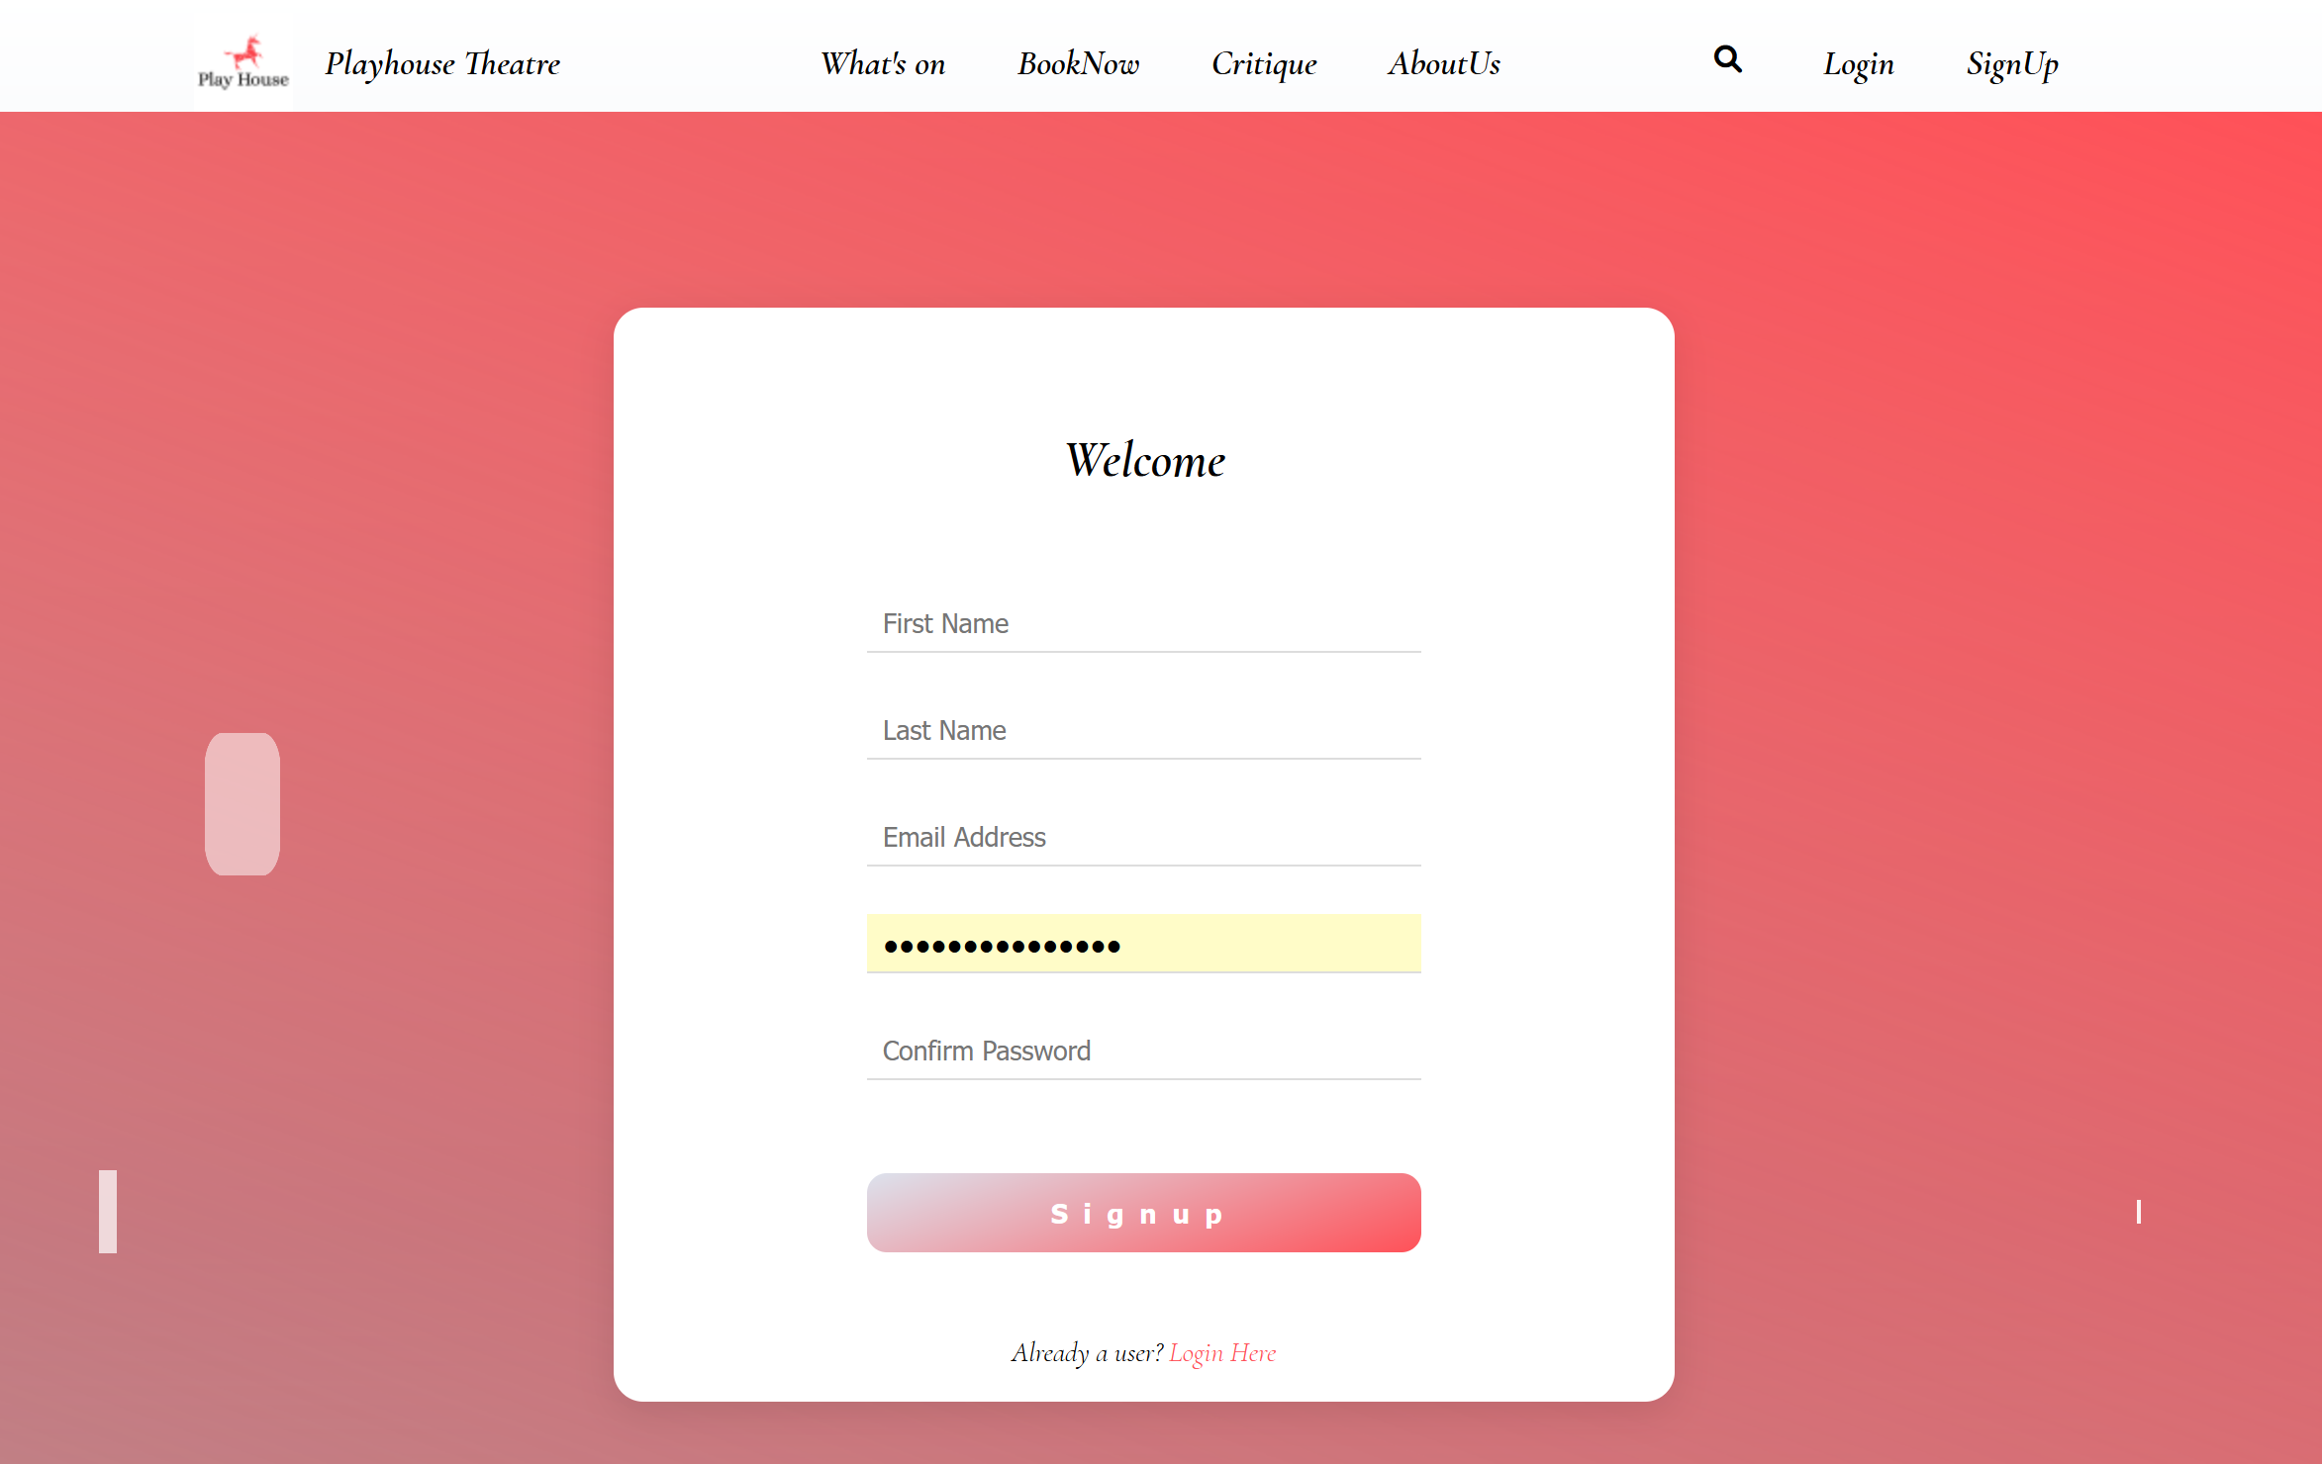

sticky header

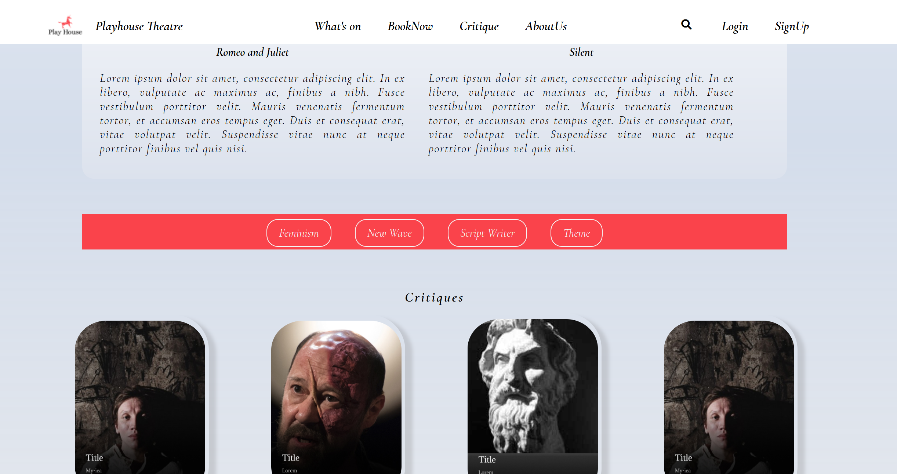

search icon

